C Value = 0.0001

Gamma = 0.0001

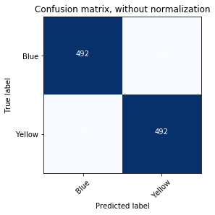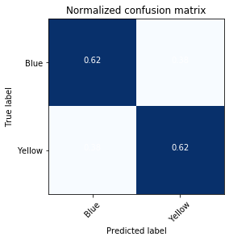

sensitivity = 0.615

specificity = 0.615

precision = 0.615

recall = 0.615

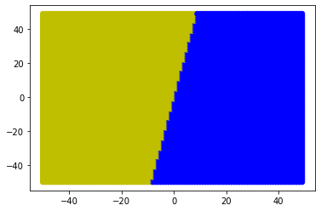

C Value = 0.0001

Gamma = 0.001

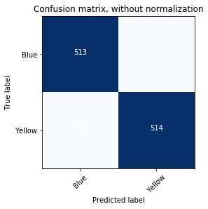 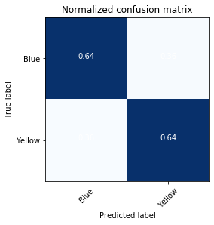

sensitivity = 0.6425

specificity = 0.64125

precision = 0.6416978776529338

recall = 0.6425

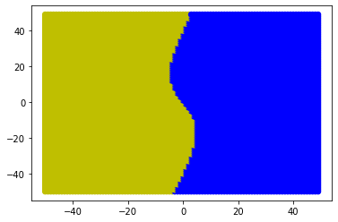

C Value = 0.0001

Gamma = 0.01

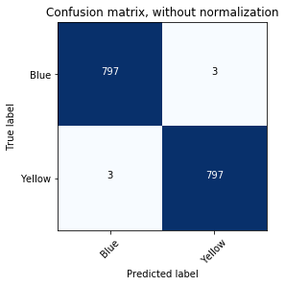 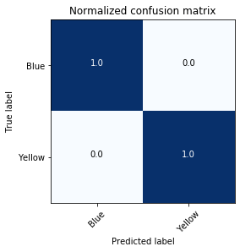

sensitivity = 0.99625

specificity = 0.99625

precision = 0.99625

recall = 0.99625

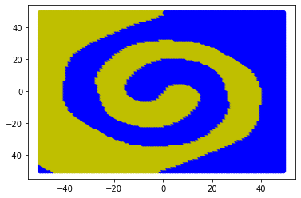

C Value = 0.0001

Gamma = 0.1

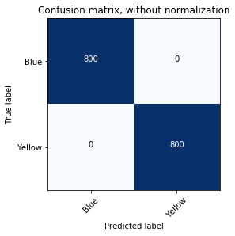

sensitivity = 1.0

specificity = 1.0

precision = 1.0

recall = 1.0

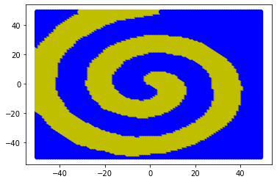

C Value = 0.0001

Gamma = 1

 

sensitivity = 1.0

specificity = 1.0

precision = 1.0

recall = 1.0

